Creative School Planning Framework
Glossary

The ‘arts’
The ‘arts’ means any creative or interpretative expression (whether traditional or contemporary) in whatever form, and includes, in particular, visual arts, theatre, literature, music, dance, opera, film, circus and architecture, and includes any medium when used for those purposes (Arts Act, 2003).
Creative Schools (CS) takes a very broad definition of the arts, spilling into related areas, including heritage, design and all parts of our creative culture.
The arts are a reflection of our culture and society – young people’s creative expression and engagement are always changing and may take a variety of forms – e.g. through coding and designing video games.
Arts education
This refers usually to the mainstream teaching and learning of the arts as part of general education.

Arts in education
This refers mostly to interventions from the realm of the arts into the education system, and can take many forms. It can include artists and arts organisations visiting schools, and also schoolchildren/young people engaging with professional artists and cultural practice in the public arena.

Learning in the arts
This is generally recognised as learning that develops ability in a particular artform or arts area.

In primary schools in Ireland, the art-subject areas are currently music, drama, visual arts and dance, although the latter sits within physical education. In post primary schools, music and visual art are available for most students as subjects assessed as part of the Junior and Senior Cycles. However, schools may develop bespoke modules in specific arts areas for Junior Cycle and Transition Year. Students have opportunities to learn about literature, poetry, theatre and film as part of their English, Irish and classical-studies subject areas. For students who wish to develop a vocation in theatre, dance, circus, film, architecture or other areas, many rely on developing these skills outside of school before reaching third level. Some Leaving Certificate Applied courses are available in the arts.

Learning through the arts
This is where the arts and related creative practices are deployed to support learning across curriculum subjects.

Artistic skills
These comprise a combination of creative, critical and technical skills. Technical skills vary across different artforms and practices. There is some crossover in the creative and critical skills required and developed across artforms. However, the application of these creative and critical skills will vary depending on the particular artform or arts practice.

Artistic quality
Artistic experiences (including learning in and through the arts) are of quality when they are ambitious, technically competent and connect with people in a lasting way.

Connection/personal response
This is a key part of artistic quality that bears repeating! Quality engagement with the arts is possible when young people’s voices and personal responses are nurtured.

Creative learning
This is most effective when:
- Children and young people are consulted at all stages of the process – they are placed centre stage in the learning process.
- School staff, artists and creative professionals and young people take part together as equals in a process of enquiry. They collaborate, explore and learn together.
- Activities and projects are journeys that are not predefined products.
- Artists and creative practitioners with a broad range of expertise – artists, architects, web designers – bring unique perspectives, ideas and skills to the learning experience.
- Creative professionals work as part of a team over a sustained period of time, rather than coming in to deliver a defined activity with minimal teacher involvement.
- Programmes focus on developing young people’s creativity skills as well as wider outcomes.
- Creative learning is possible in a range of contexts.

Creative learning is an opportunity to think broadly about how we learn and the possibility of working with a wide range of people in the community and beyond. It leads to confident, motivated, inquisitive, collaborative, imaginative, resilient, disciplined and effective children/young people who achieve their potential.
Creative children/young people
They:
- Are open-minded and have a questioning attitude to learning and knowledge.
- Are self-managing and see themselves and their peers as important resources to support their learning.
- Provoke questions, identify problems and open up lines of enquiry.
- Use a wide range of intelligences and learning styles.
- Have a range of thinking skills that encourage them to come up with ideas and problems, choose which to pursue, and follow through in an effective and efficient way.
- Critique their own work and accept constructive ideas and criticism from others.
- Have the opportunity and impetus to work constructively, both individually and in teams of different sizes and compositions.
- Take account of the influence of process, product and audience.

Creative teaching
This focuses on the teacher, and employs a creative pedagogy that draws on arts/creative techniques. It is most effective when teachers:
- Use innovative approaches to teaching, curriculum delivery and assessment.
- Prioritise strategies that engage children/young people.
- Model creativity and adapt their strategies to meet the needs of children/young people.
- Develop material and approaches that fire children/young people’s interests and motivation to learn.
- Make cross curricular and wider links.
- Focus on the relevance for the learner, and plan on the basis of the learner’s starting point, progress and experiences.
- Collaborate with children/young people and support them to take ownership of the experiences.
- Provide exciting, memorable and challenging lessons.
- Make the design and use of learning spaces an integral part of their planning, and use space flexibly and imaginatively.
- Develop effective teacher–pupil relationships.
- Provide the space for children/young people to plan their own learning and to reflect and evaluate progress.
- Understand and use the ‘High-Functioning Classroom’, which is illustrated below.

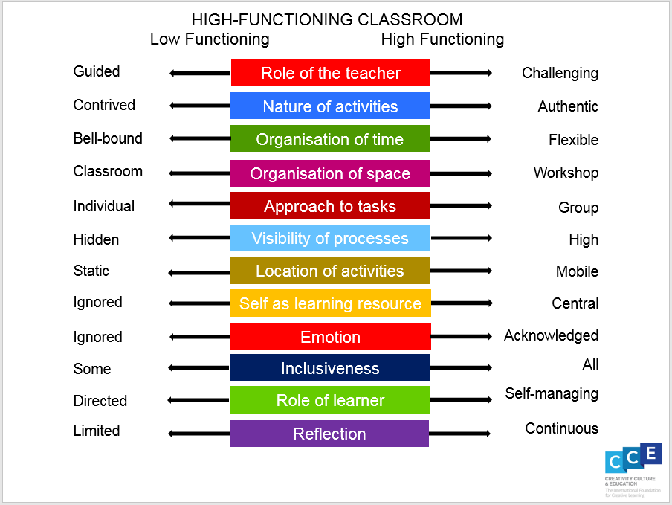

This leads to interested, excited and motivated children/young people.

Creative skills
The Creative Habits of Mind developed for Creativity, Culture and Education by the Centre for World Learning at Winchester University and used by the OECD in its work on creative and critical thinking skills as part of the inclusion of creativity in the PISA 2022 are as follows:

Inquisitive
Wondering and questioning
Exploring and investigating
Challenging assumptions
Imaginative
Playing with possibilities
Making connections
Using intuition
Persistent
Tolerating uncertainty
Sticking with difficulty
Daring to be different

Collaborative
Co-operating appropriately
Giving and receiving feedback
Sharing the ‘product’
Disciplined
Crafting and improving
Developing techniques
Reflecting critically

These skills are featured across the school curriculum in Ireland, in different ways.

